Direct Object as a Verb Complement

✅ What Is a Direct Object?
# Source: AI Source: Provided by: [Data Path: Persons Table -> ID Column: 1, Name_En Column: Motasem Essam] -> From: [ChatGPT] on [8/4/2025]
A direct object is a noun, pronoun, or noun phrase that receives the action of a transitive verb. It is one of the most common and fundamental types of verb complements, as it completes the meaning of the verb.

🔸 Structure:
# Source: AI Source: Provided by: [Data Path: Persons Table -> ID Column: 1, Name_En Column: Motasem Essam] -> From: [ChatGPT] on [8/4/2025]
- Verb + Direct Object

🔸 Examples:
# Source: AI Source: Provided by: [Data Path: Persons Table -> ID Column: 1, Name_En Column: Motasem Essam] -> From: [ChatGPT] on [8/4/2025]
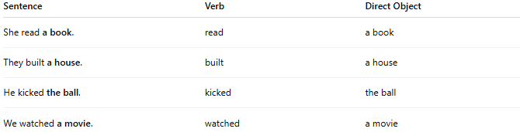
Sentence | Verb | Direct Object
She read a book. | read | a book
They built a house. | built | a house
He kicked the ball. | kicked | the ball
We watched a movie. | watched | a movie

🔸 Why It's a Verb Complement:
# Source: AI Source: Provided by: [Data Path: Persons Table -> ID Column: 1, Name_En Column: Motasem Essam] -> From: [ChatGPT] on [8/4/2025]
The direct object provides the essential target or recipient of the verb’s action. Without it, the sentence would be incomplete or the verb’s meaning unclear for transitive verbs.
🟢 Example:
- ✅ "She read a book."
- ❌ "She read." (incomplete – read what?)

